**PROGRAM 6**

# Query Editor, Connecting the data from the Excel Source , Clean , Transform the data.

**Step 1:**

**Creating a New Report in Power BI**

* Open Power BI Desktop and click on 'File' > 'New Report' to create a new report.
* Power BI Desktop interface with the "New Report" option highlighted.

**Connecting Data from Excel Source**

* + - Click on 'Home' > 'Get Data' > 'File' > 'Excel'
    - Select the Excel file containing the data.

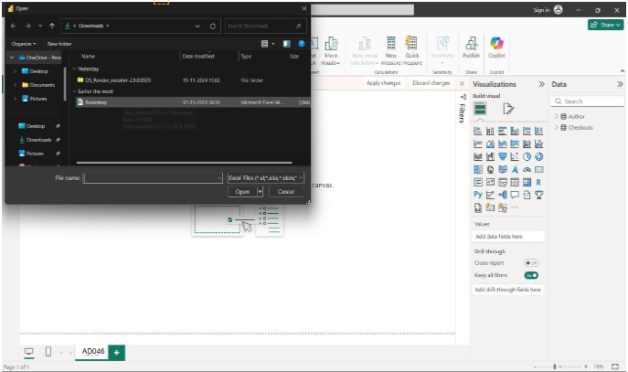

**Step2:**

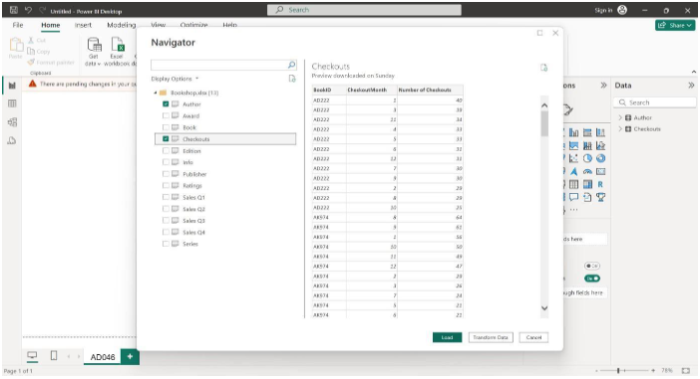Select the column names that is required to transform the data and load the data.

**Step3:**

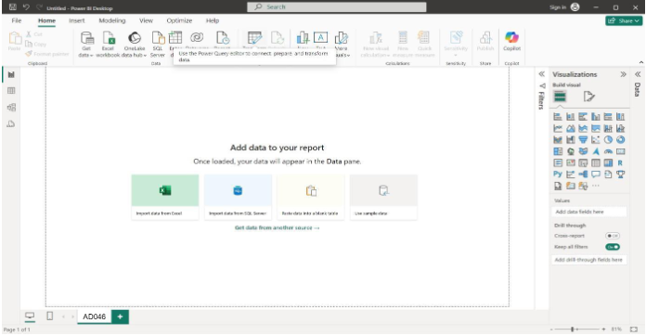Now select the TRANSFORM DATA option.

**STEP4:**

**Renaming the column name :**

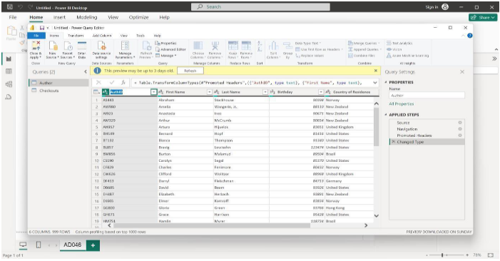Double click on the column and rename it as per requirement.

**STEP5:**

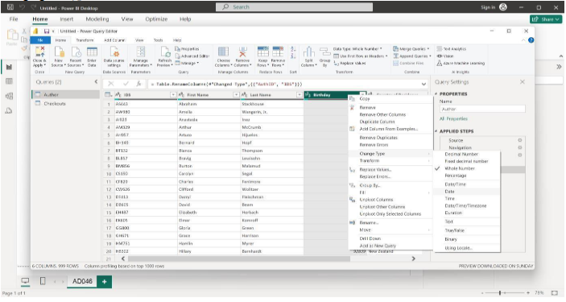Changing the type of the data (to decimal,whole number etc..)

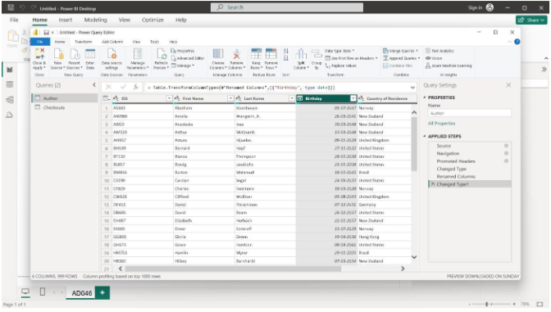

**STEP6:**

**KEEPING THE REQUIRED ROWS AND COLUMNS :**

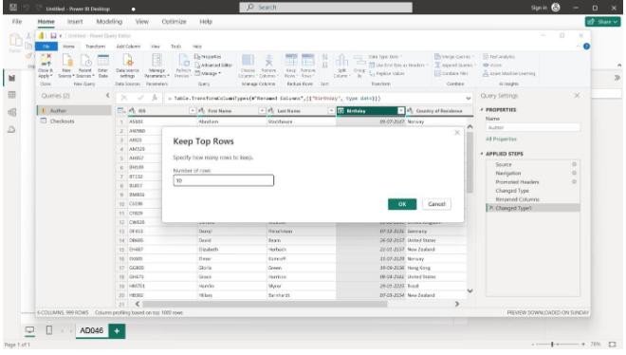Enter the number of rows to keep.

**STEP7:**

**REMOVING THE ROWS :**

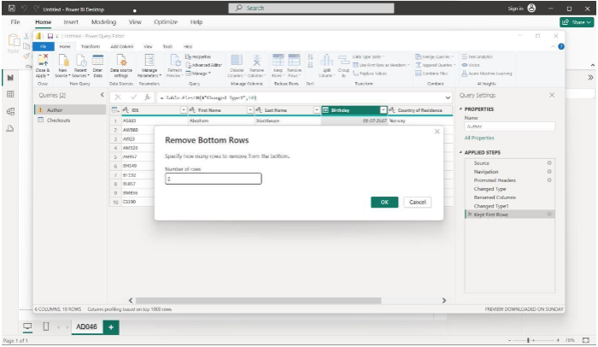

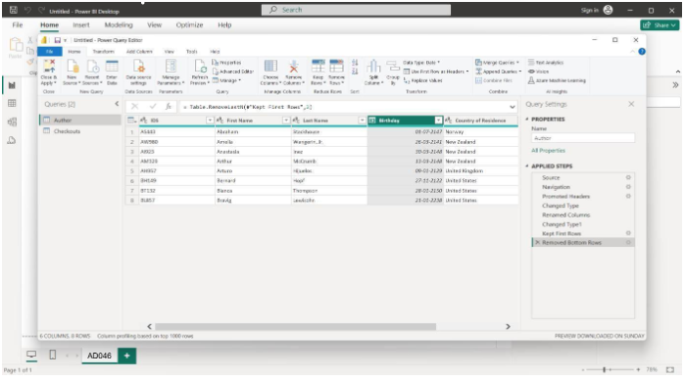

**STEP8:**

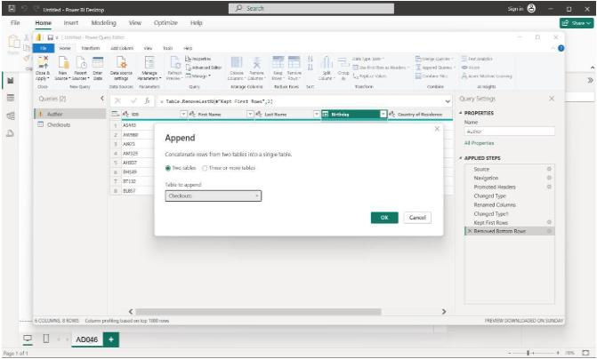**APPENDING THE ROWS :**

